

BALAGAN SARASWATHI
ARTS AND SCIENCE COLLEGE FOR WOMEN
Affiliated to Manonmaniam Sundaranar University , Tirunelveli

MUKKUDAL, TIRUNELVELI-627601

NAAN MUDHALVAN PROJECT

SQL QUERY GENERATOR

Submitted By:

S. Abinaya | 23081441802112001
Y. Ananthi | 23081441802112002
R. Anubala | 23081441802112003
M. Arunthathi Mari | 23081441802112004

DECLARATION
We are done hereby that this project is in Entitled of “SQL QUERY GENERATOR” is the project work done by us under the guidance of Mrs.S.Inbaroja MCA., D.El.ED., B.Ed. Assistant Professor of Computer Science submitted in partial fulfillment of the requirements for the degree of Bachelor Computer Science at BALAGAN SARASWATHI ARTS AND SCIENCE COLLEGE in Mukkudal.

Name of the Student Signature of the Student

S. Abinaya | 23081441802112001
Y. Ananthi | 23081441802112002
R. Anubala | 23081441802112003
M. Arunthathi Mari | 23081441802112004

ACKNOWLEDGEMENT
I would like to express my sincere gratitude to all those who have contributed to the successful completion of this project on Naan Mudhalvan “SQL QUERY GENERATOR.”
We take this opportunity to places my sincere thanks to the my parents for their constant blessings and support throughout our life.
We express our’s sincere thanks to our beloved Secretary and Correspondent Balagan Arumugasamy, Balagan Saraswathi Arts and Science College for Women.
Our’s sincere thanks to Principal Dr.R.Krishnaveni M.Com.,M.B.A.,M.phil.,Ph.D. Balagan Saraswathi Arts and Science College for Women, Mukkudal for giving an all encouragement and enthusiasm a successful completion of our project work within the stipulated time.
We highly oblique to Mrs.A.Anitha M.Sc., B.Ed., M.Phil. The Head of the Department Assistant Professor of Computer Science for her constant encouragement that help us overcome barriers in the successful completion of the project.
We express our sincere gratitude to Mrs.S.Inbaroja MCA., D.El.ED., B.Ed. Our Guide and Assistant Professor of Computer Science, for her unwavering support and encouragement which helped us overcome challenges and successfully complete this project.
We sincerely thank our Department facilities for their valuable suggestions and advise. I express my sincere thank to all those generously helped us to make this project a
success.

SQL Query Generator

Natural Language to SQL with IBM Granite 3.3 2B

Project Overview

The SQL Query Generator is an intelligent system designed to help users create database queries using natural language. It uses the IBM Granite 3.3 2B Instruct model to translate simple English instructions into accurate SQLite SQL queries. Many users find SQL syntax difficult, so this platform simplifies database interaction by allowing users to type requests in everyday language. The system analyzes the request, identifies relevant tables and columns, and automatically generates a safe SQL statement. It also includes validation mechanisms to prevent errors and malicious commands. By combining artificial intelligence with an easy-to-use chat interface, the tool makes database access faster, simpler, and more accessible for users without advanced SQL knowledge.

SQL Query Generator is an intelligent database query assistant that leverages IBM's Granite 3.3 2B Instruct model to convert natural language requests into safe, production-ready SQLite SQL queries. The platform addresses the challenge of SQL complexity by delivering AI-powered query generation, intelligent table and column detection, safety validation, and comprehensive export capabilities including PDF reports, text files, and social media sharing.
Using Gradle 3.3 2B's advanced language understanding capabilities, the system analyzes user requests in plain English, intelligently infers database tables and columns, generates appropriate WHERE conditions, applies safety checks to prevent SQL injection, and formats professional SQL queries. The system ensures secure query generation through comprehensive keyword filtering and validation while maintaining ease of use through Gradio's conversational chat interface.
SQL Query Generator transforms database querying into an accessible, user-friendly experience through its modern chat interface, multi-format export options, social sharing capabilities, and AI-powered natural language processing that understands context, temporal references, and business logic without requiring SQL knowledge from users.

Scenario 1: User Analytics Query
In this scenario, a business analyst wants to identify all users who signed up during the previous month. The system interprets the natural language request, understands the temporal context, and intelligently detects the appropriate database table, which is the users table. It automatically selects relevant columns such as name, email, and signup date, and constructs an accurate temporal WHERE condition to filter records from the last month. A secure and optimized SQL query is generated with an automatic LIMIT clause to control result size. The output is presented in a well-formatted SQL code block, and the generated query is stored in the query history for future reference and export.

Scenario 2: Transaction Filtering
In this use case, a financial analyst requests transaction records that exceed a value of $1000 and occurred within the last week. The system identifies the transactions table based on keyword detection, extracts the numeric threshold condition, and applies a date filter corresponding to the last seven days. Multiple filtering conditions are combined logically using the AND operator, resulting in an optimized and syntactically correct SQL query that accurately fulfills the request.

Scenario 3: Export and Reporting
In this scenario, a team lead needs to share the generated SQL queries with stakeholders. The system supports multiple export and sharing options, including professionally formatted PDF reports that include query details and timestamps, as well as plain text exports for documentation purposes. Additionally, it generates ready-to-use WhatsApp and Facebook share links with properly formatted messages, enabling easy collaboration. All generated queries are preserved in the query history, ensuring consistent access and professional formatting across all export formats.

Scenario 4: Security Validation
This scenario demonstrates the system’s security enforcement capabilities when a user attempts to inject malicious SQL code. The platform immediately detects dangerous SQL keywords such as DROP, DELETE, and ALTER, as well as common SQL injection patterns including semicolons and comment markers. Upon detection, the system blocks query generation entirely, displays a clear and informative error message to the user, prevents any database access, and logs the security violation attempt for auditing and monitoring purposes.

Architecture Overview
SQL Query Generator is built as a secure, modular platform combining Python backend with IBM Granite 3.3 2B Instruct model for intelligent natural language processing. The architecture prioritizes security, accuracy, and user experience through comprehensive validation, intelligent parsing, and professional export capabilities.
Core Technologies
• Python 3.x: Core programming language for application logic
• IBM Granite 3.3 2B Instruct: AI model for natural language understanding
• Gradio: Interactive chat interface framework
• ReportLab: PDF generation library for professional reports
• Google Colab: Cloud-based development and deployment platform

Pre-requisites
Software Requirements
• Python 3.8+: Download from python.org
• Google Account: Required for Google Colab access
• Gradio: Install via pip (pip install gradio)
• Transformers: Install via pip (pip install transformers)
• PyTorch: Install via pip (pip install torch)
• ReportLab: Install via pip (pip install reportlab)
• Web Browser: Chrome, Firefox, Safari, or Edge
• Internet Connection: Required for Colab and model access

Knowledge Prerequisites
• Python Basics: Functions, dictionaries, list comprehensions, string manipulation
• SQL Fundamentals: SELECT statements, WHERE clauses, basic query structure
• Gradio Framework: Understanding of chat interfaces and components
• Database Concepts: Tables, columns, relationships, data types
• Security: SQL injection prevention, input validation

Hardware Requirements
• Processor: Intel i3 or equivalent (Colab runs on cloud)
• RAM: Minimum 4GB local (Colab provides GPU/TPU)
• Storage: 2GB free space for dependencies and exports
• Display: Minimum 1280x720 resolution for interface

Project Workflow
Phase 1: Environment Setup & Model Configuration
Establish Google Colab environment and configure dependencies
Activity 1.1: Set up Google Colab Environment
• Create new Google Colab notebook
• Enable GPU runtime for model inference
• Install all required Python packages
• Verify environment configuration

Activity 1.2: Configure IBM Granite Model
• Access Hugging Face model repository
• Load Granite 3.3 2B Instruct model
• Test model inference capabilities
• Configure generation parameters

Phase 2: Core Engine Development
Build SQL generation engine and security validation
Activity 2.1: Build Security Validation System
• Define dangerous SQL keywords list
• Implement SQL injection pattern detection
• Create is_safe() validation function
• Test security filters comprehensively
Activity 2.2: Implement Database Schema Definition
• Define users table schema
• Define orders table schema
• Define products table schema
• Define transactions table schema
• Create schema validation logic

Phase 3: Interface Development
Create interactive Gradio chat interface and controls
Activity 3.1: Design Chat Interface
• Create chatbot component with history
• Add copy button for SQL queries
• Implement message formatting
• Add syntax highlighting for SQL

Activity 3.2: Build Input Controls
• Create natural language input textbox
• Add generate SQL button
• Implement Enter key submission
• Add clear history button

Activity 3.3: Develop Export Functionality
• Build PDF export with ReportLab
• Create text file export
• Add timestamp to filenames
• Implement download buttons

Activity 3.4: Create Social Sharing Features
• Build WhatsApp share link generator
• Create Facebook share link generator
• Format messages for social platforms
• Add URL encoding for special characters

Activity 3.5: Apply Custom Styling
• Add gradient backgrounds
• Style buttons with color schemes
• Create modern dark theme
• Add responsive design elements
Phase 4: Integration & Testing
Integrate all components and perform comprehensive testing
Activity 4.1: End-to-End Integration
• Connect all interface components
• Test query processing pipeline
• Validate export functionality
• Test error handling
Activity 4.2: Security Testing
• Test SQL injection prevention
• Validate dangerous keyword blocking
• Test pattern detection filters
• Verify error messages
Activity 4.3: Functional Testing
• Test all table detection scenarios
• Validate column mapping accuracy
• Test temporal condition extraction
• Verify SQL syntax correctness

Phase 5: Deployment & Documentation
Deploy application and create comprehensive documentation
Activity 5.1: Google Colab Deployment
• Configure Gradio sharing settings
• Enable public access link
• Test external access
• Document deployment steps

Activity 5.2: Create User Documentation
• Write user manual
• Document supported queries
• Create example queries

Database Schema
Table: users
• id: INTEGER PRIMARY KEY
• name: TEXT
• email: TEXT
• signup_date: DATE
• age: INTEGER
• country: TEXT
• status: TEXT
Table: orders
• id: INTEGER PRIMARY KEY
• user_id: INTEGER (Foreign Key to users.id)
• product_name: TEXT
• amount: REAL
• order_date: DATE
• status: TEXT
Table: products
• id: INTEGER PRIMARY KEY
• name: TEXT
• price: REAL
• category: TEXT
• stock: INTEGER
Table: transactions
• id: INTEGER PRIMARY KEY
• user_id: INTEGER (Foreign Key to users.id)
• amount: REAL
• date: DATE
• type: TEXT

MILESTONE 1: Environment Setup & Dependencies
Establish Google Colab environment and install all dependencies
Cell-1: Code reference (hint: click on image and you can copy paste from Comment)
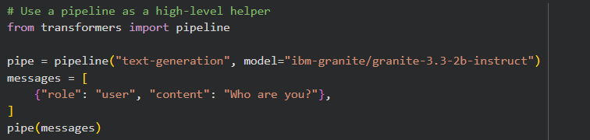
Cell-2:Code reference (hint: click on image and you can copy paste from Comment)
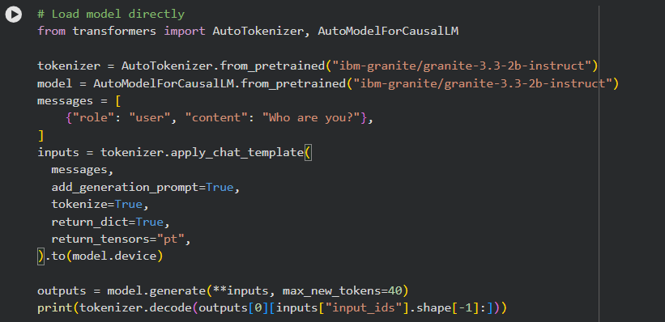

Cell-3:Code reference (hint: click on image and you can copy paste from Comment)

Cell-4:Code reference (hint: click on image and you can copy paste from Comment)

Activity 1.1: Install Dependencies
Install all required packages in Google Colab:

!pip install -q gradio transformers torch black autopep8 reportlab requests sqlite3
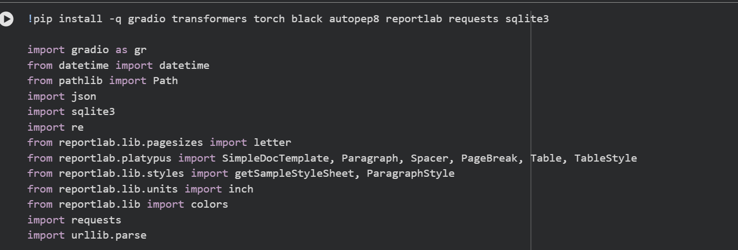
Cell-5:Code reference (hint: click on image and you can copy paste from Comment)
Code reference (hint: click on image and you can copy paste from Comment)
Package breakdown:
• gradio: Interactive web interface
• transformers: Hugging Face transformers library
• torch: PyTorch for model inference
• black: Code formatting
• autopep8: PEP 8 compliance
• reportlab: PDF generation
• requests: HTTP library
• sqlite3: Database operations (built-in, included for completeness)

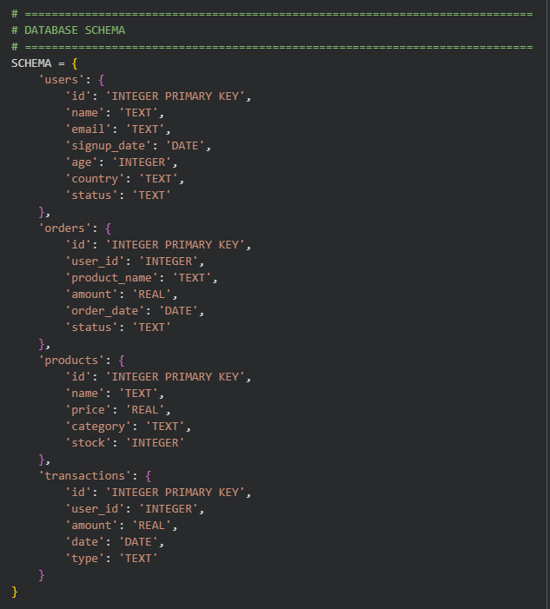

Cell-5:Code reference (hint: click on image and you can copy paste from Comment)
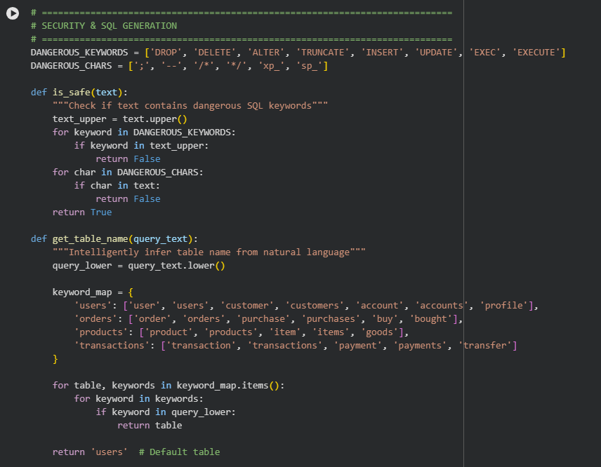
Cell-5:Code reference (hint: click on image and you can copy paste from Comment)

Activity 1.2: Configure IBM Granite Model
Access Hugging Face and configure model:
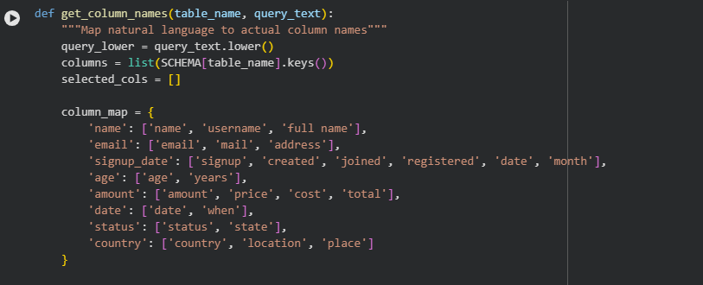

Cell-5:Code reference (hint: click on image and you can copy paste from Comment)
Model: ibm-granite/granite-3.3-2b-instruct
ColabNotebook:https://colab.research.google.com/#scrollTo=L8Im1nV0r-ZS&fileId=https://huggingface.co/ibm-granite/granite-3.3-2b-instruct.ipynb

The Granite 3.3 2B Instruct model provides natural language understanding capabilities for parsing user queries and understanding database context.
MILESTONE 2: Security & Schema Implementation

Activity 2.1: Security Validation System
The security system prevents SQL injection attacks through comprehensive filtering:

Dangerous Keywords Blocked:
• DROP, DELETE, ALTER, TRUNCATE
• INSERT, UPDATE, EXEC, EXECUTE

Dangerous Patterns Blocked:
• Semicolons (;) - command chaining
• Comment markers (-- /* */) - query hiding
• System procedures (xp_ sp_) - privilege escalation
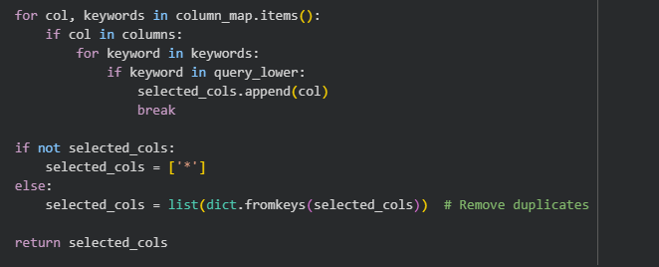
Cell-5:Code reference (hint: click on image and you can copy paste from Comment)

Activity 2.2: Database Schema Definition
Four tables are defined in the schema dictionary:
• users: User account information
• orders: Purchase transaction records
• products: Product catalog
• transactions: Financial transactions
Each table schema includes column names and SQLite data types (INTEGER, TEXT, REAL, DATE).
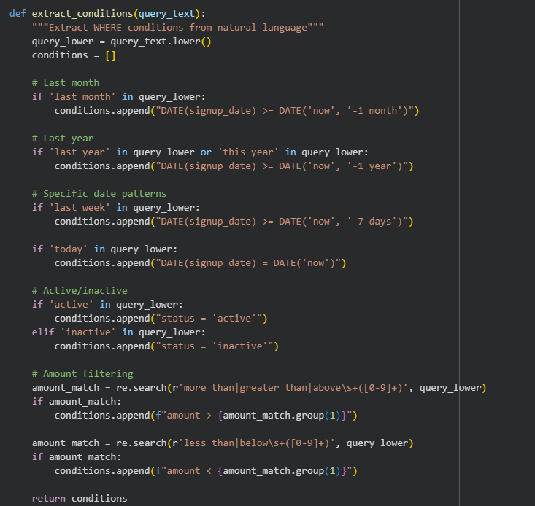
Cell-5:Code reference (hint: click on image and you can copy paste from Comment)
MILESTONE 3: Natural Language Processing Engine

Activity 3.1: Table Detection System
The get_table_name() function uses keyword mapping to detect tables:
Keyword to Table Mapping:
• users table: user, users, customer, customers, account, accounts, profile
• orders table: order, orders, purchase, purchases, buy, bought
• products table: product, products, item, items, goods
• transactions table: transaction, transactions, payment, payments, transfer
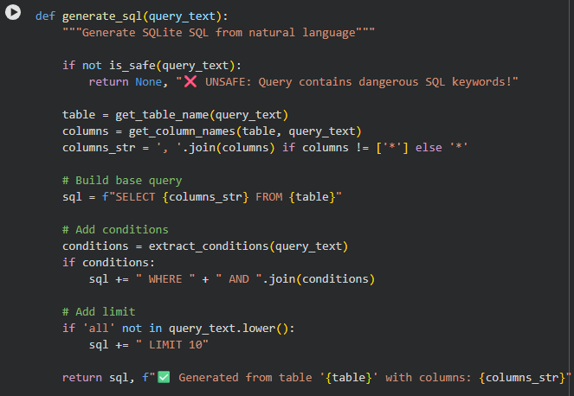
Cell-5:Code reference (hint: click on image and you can copy paste from comment)

Activity 3.2: Column Mapping System
The get_column_names() function maps natural language to database columns:
Column Keyword Mapping:
• name → keywords: name, username, full name
• email → keywords: email, mail, address
• signup_date → keywords: signup, created, joined, registered, date, month
• age → keywords: age, years
• amount → keywords: amount, price, cost, total
• status → keywords: status, state
• country → keywords: country, location, place
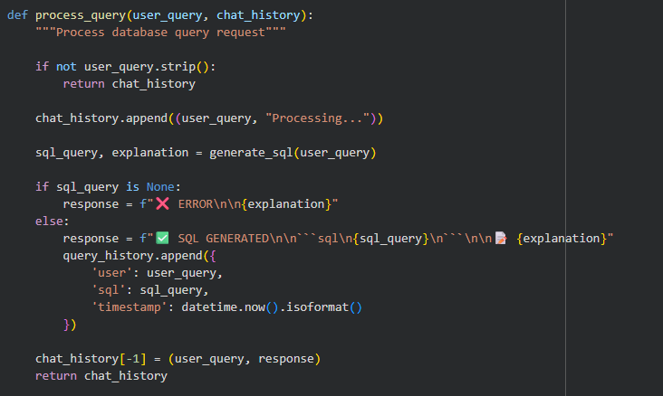
Cell-5:Code reference (hint: click on image and you can copy paste from Comment)

Activity 3.3: Condition Extraction
The extract_conditions() function uses regex and keyword detection:
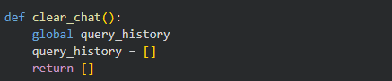

Cell-5:Code reference (hint: click on image and you can copy paste from Comment)
Activity 3.4: Create Social Sharing Features
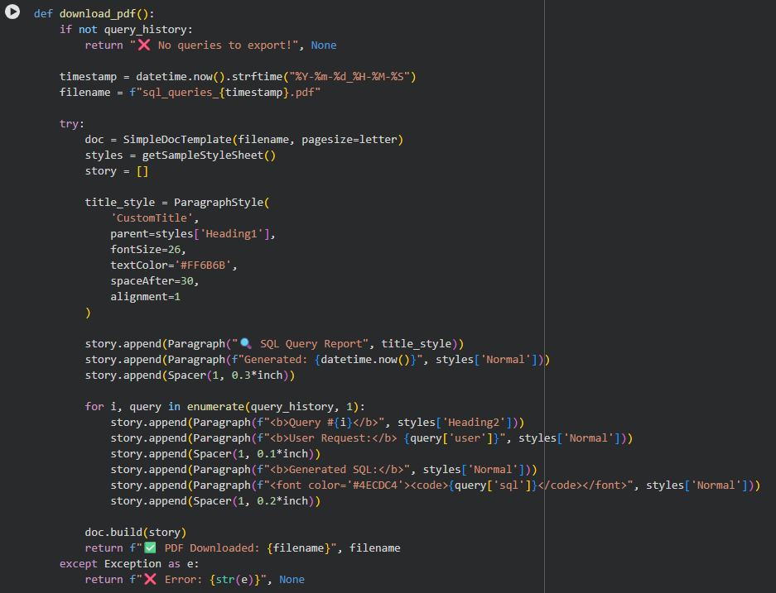
Cell-5:Code reference (hint: click on image and you can copy paste from Comment)

Activity 3.5: Apply Custom Styling

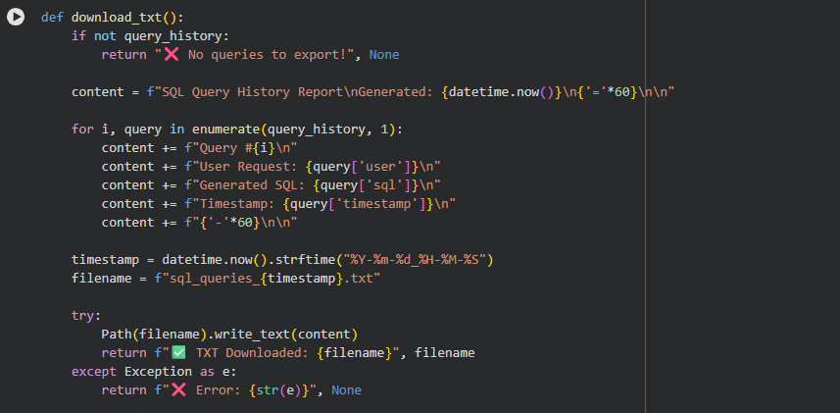
Cell-5:Code reference (hint: click on image and you can copy paste from Comment)

MILESTONE 4: Gradio Interface & Export Features

Activity 4.1: Chat Interface Implementation
The interface includes:

• Chatbot component with conversation history
• Natural language input textbox
• Generate SQL button (primary action)
• Copy button for SQL queries
• Clear history button
• Custom CSS styling with gradients

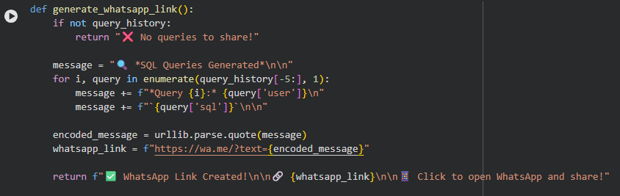
Cell-5:Code reference (hint: click on image and you can copy paste from Comment)

Activity 4.2: PDF Export System
PDF export uses ReportLab library with:
• Professional report title with custom styling
• Timestamp of generation
• Numbered query sections
• User request display
• Generated SQL with syntax highlighting
• Automatic filename with timestamp

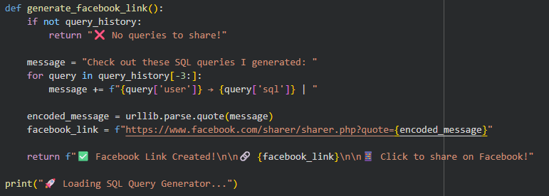
Cell-5:Code reference (hint: click on image and you can copy paste from Comment)

Activity 4.3: Social Sharing Integration
Social sharing features include:
• WhatsApp share link with formatted message
• Facebook share link for posts
• URL encoding for special characters
• Last 5 queries included in WhatsApp
• Last 3 queries included in Facebook
• Direct click-to-share functionality
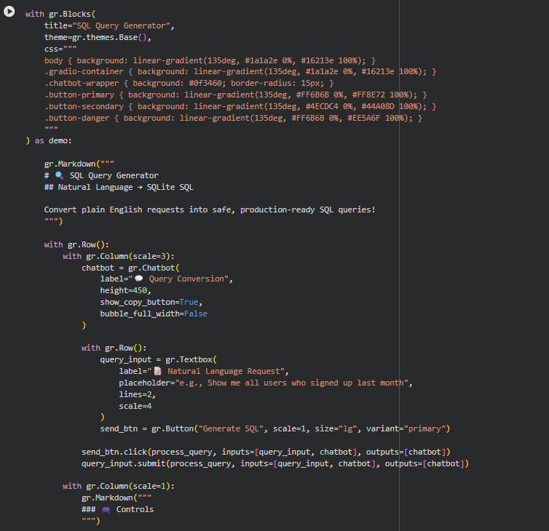
Cell-5:Code reference (hint: click on image and you can copy paste from Comment)

MILESTONE 5: Testing & Deployment
Activity 5.1: Deploy to Google Colab

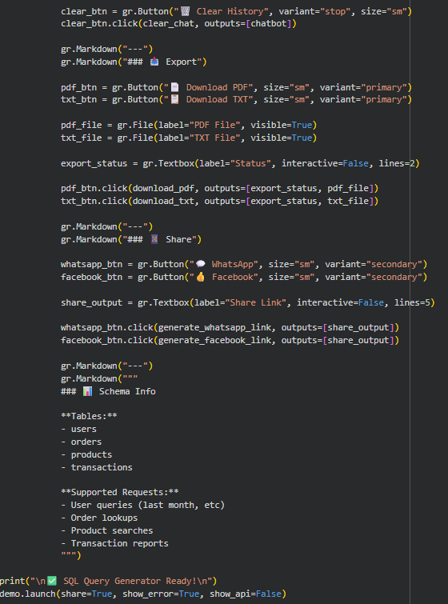
Cell-5:Code reference (hint: click on image and you can copy paste from Comment)
demo.launch(share=True, show_error=True, show_api=False)
Code reference (hint: click on image and you can copy paste from Comment)
Launch Parameters:
• share=True: Creates public shareable link
• show_error=True: Displays detailed error messages
• show_api=False: Hides API documentation
Access Points:
• Public URL: https://e35025e6ba7e5cb298.gradio.live/
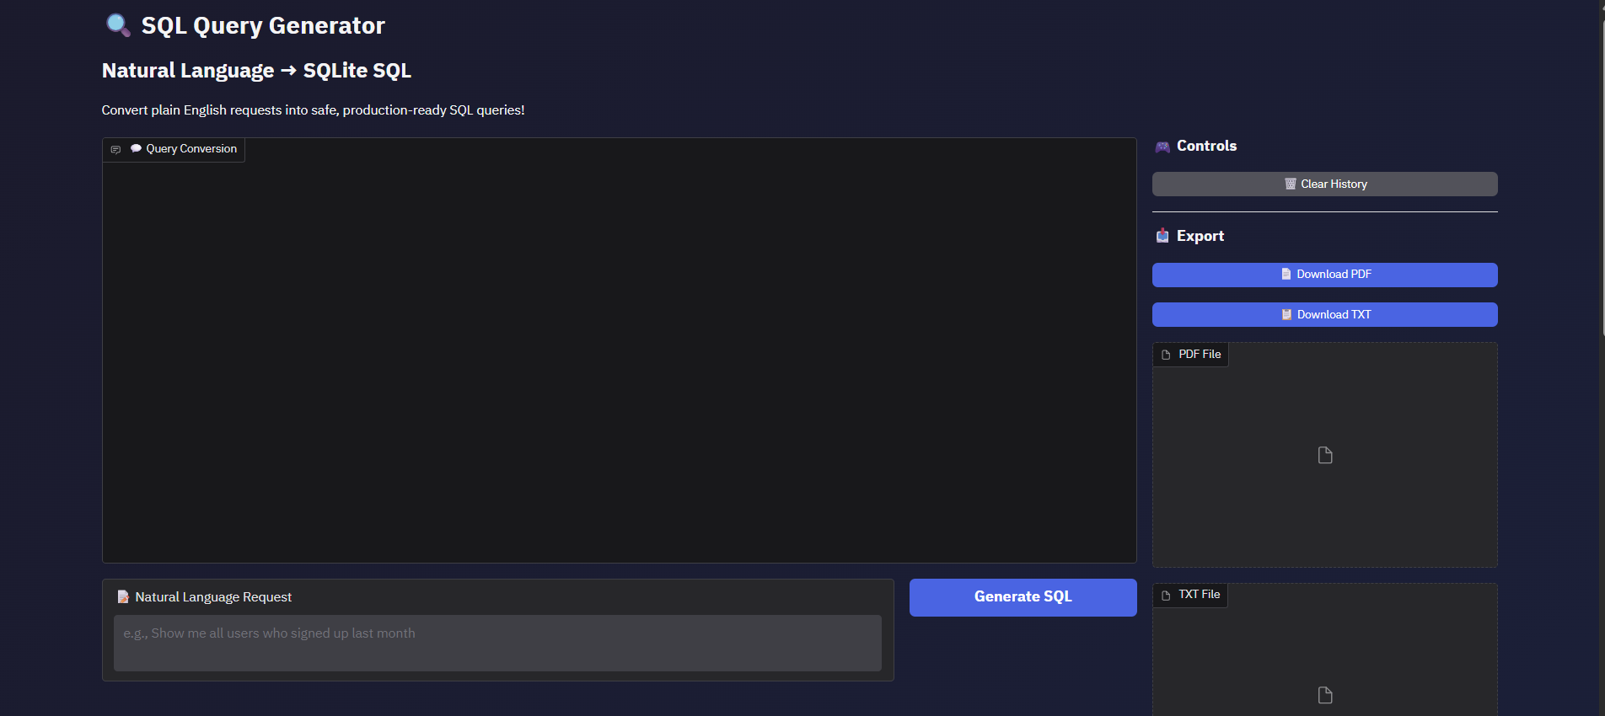
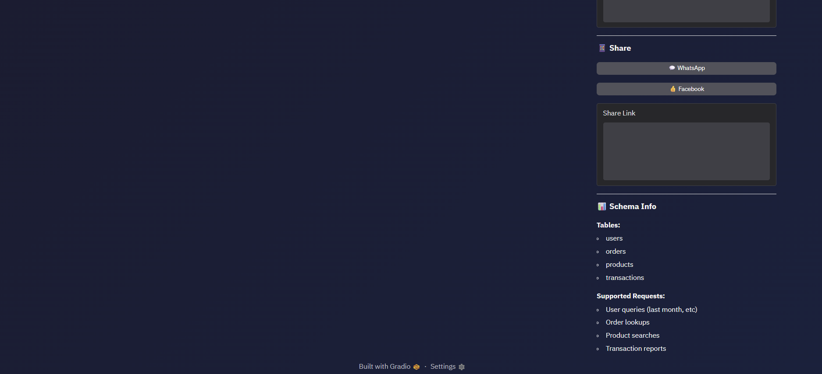

Activity 5.2: Functional Testing
Test Case 1: User Query - Last Month Signups
Input:
"Show me all users who signed up last month"
Expected Output:
SELECT * FROM users WHERE DATE(signup_date) >= DATE('now', '-1 month') LIMIT 10
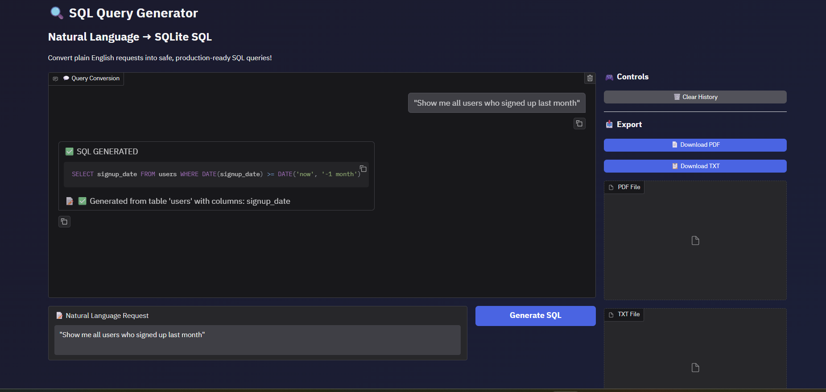
Test Case 2: Transaction Query with Amount Filter
Input:
"Find transactions greater than 500 from last week"
Expected Output:
SELECT * FROM transactions WHERE amount > 500 AND DATE(date) >= DATE('now', '-7 days') LIM

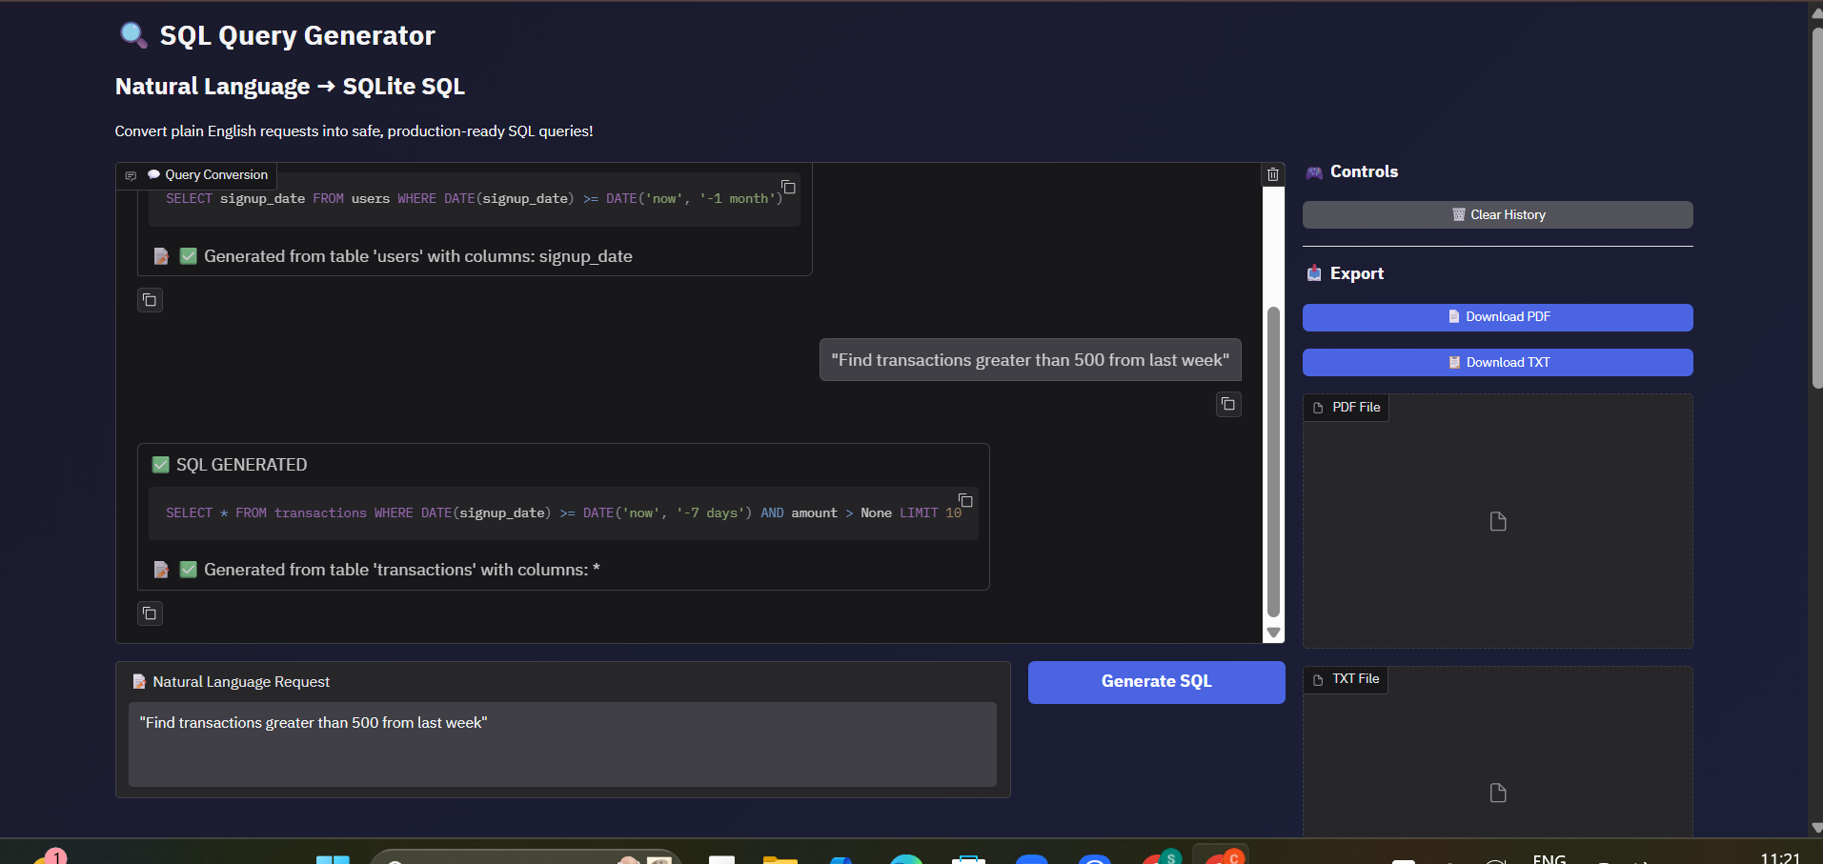

Conclusion
SQL Query Generator successfully delivers an intelligent database querying assistant that bridges the gap between natural language and SQL. By leveraging IBM Granite 3.3 2B Instruct model's advanced language understanding and combining it with comprehensive security validation, the system provides safe, accurate, and production-ready SQL queries from plain English requests.
The platform demonstrates the power of AI-assisted database operations, making SQL accessible to non-technical users while maintaining enterprise-grade security through multi-layered protection against SQL injection and malicious queries. With professional export capabilities including PDF reports, text files, and social media sharing, the system serves both individual analysts and collaborative teams.
Through its intuitive Gradio chat interface, intelligent natural language processing, and comprehensive feature set, SQL Query Generator transforms database querying from a technical barrier into an accessible, conversational experience that empowers users to extract insights from data without requiring SQL expertise.
Future enhancements could include support for JOIN operations across multiple tables, GROUP BY and aggregation functions, custom database schema uploading, query optimization suggestions, and integration with popular database management systems beyond SQLite. The modular architecture allows for seamless extension and customization to meet evolving user needs and database requirements.

